**USER ADMINISTRATION**

USERS ARE OF 3 TYPES:

1. ROOT
2. SYSTEM USERS
3. NORMAL USERS

|  |  |  |  |
| --- | --- | --- | --- |
| **COL** | **ROOT** | **SYSTEM USERS** | **NORMAL USERS** |
| UID | 0 | 12499 | 500 onwards |
|  | Root user will be automatically create when the system is installed. | System user will be automatically created. | Normal user will be create by root.  Normal user have basic privileges. |
|  |  |  |  |
|  |  |  |  |

If the status of echo $? Run successfully then it will show 0.

When user types some garbage value then the result will be 127.

If it show 1 then command is not run successfully.

For creating user:

Useradd ram

For setting password

Passwd ram

For

/etc/passwd

Ram : x : 501: 501 :: /home/ram : /bin/bash

Username : password : user id : group id : comment field : home directory : login shell

**How many shells are there?**

/bin/bash

/bin/csh

/bin/dash

/bin/sh

Bin/tcsh

/sbin/nologin

**Cd /etc/shadow**

If file show

!! = password is not set for the user

$-/ = encrypted password

**Basic root administration:**

Group administration: When you create a user, with the same name of user is aslo created

If you create user called amol, then amol group will also be created.

Groups are of 2 types:

1. Primary
2. Default Primary – when u create user the same name group is also be created
3. Customize Primary –

If it a default primary only one member is allowed.

1. Secondary

**HOW TO CREATE A GROUP:**

Groupadd Capgemini

We have 3 commands to create user or group:

Useradd or groupadd

Usermod or groupmod

Userdel or groupdel

**USER AND GROUP ADMINISTRATION ADVANCED:**

Cat /etc/passwd | grep ram

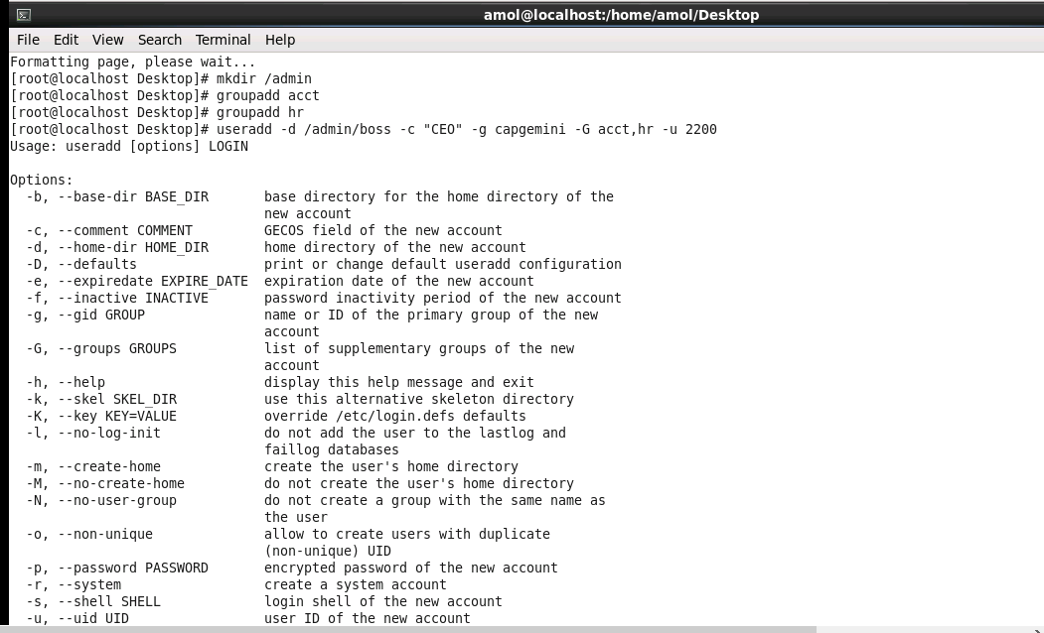



We should not change primary group and home directory with the usermod command instead of that use useradd command.

**HOW TO CHANGE THE LOGIN NAME:**

Usermod –l newram ram

**HOW USER CAN LOGIN WITHOUT PASSWORD:**

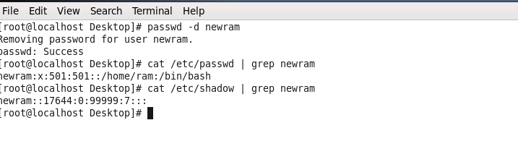

This newram cannot login remotely. Bcoz for remote login password is essential.

**HOW TO LOCK THE USER:**

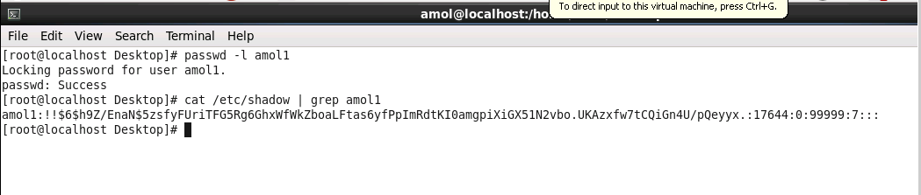

For unlock use –u amol1

**HOW TO CHANGE GROUP ID :**

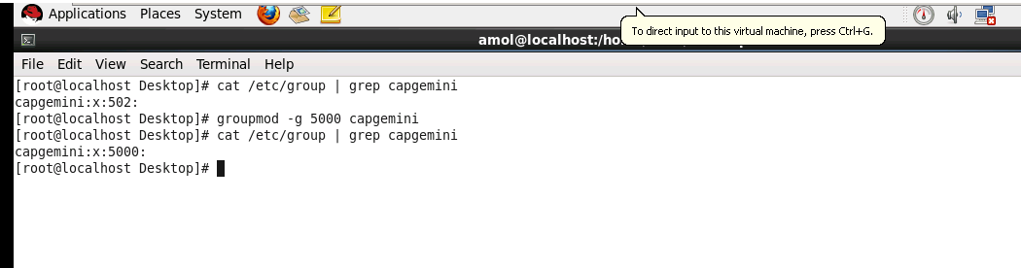

**HOW TO CHANGE THE NAME OF THE EXISTING GROUP:**

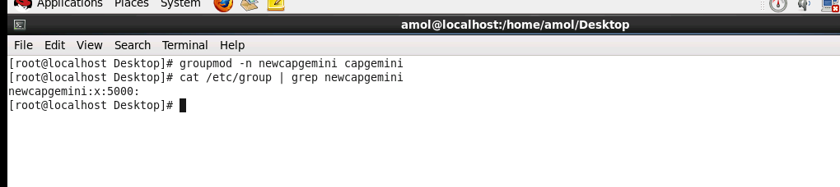

How to add users in group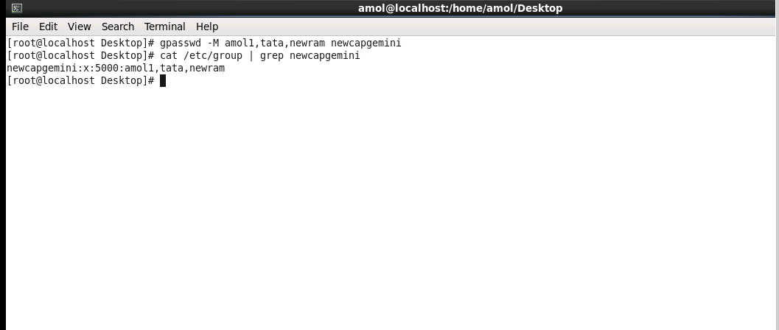

Create a group named “sysadmin”

A user ram and sam should belongs to manager group as a primary group

HR & admin as secondary group. Home directory will be /vvi/username

A user “natasha” should be “redhat123”

Create a user “block” he should not able to login, although he have a valid password

**PERMISSION**

**TYPES OF FILE PERMISSION:**

Read ® - you can view a file’s contents

Write (w)- You can change or delete the file

Execute (x) – you can run the file as a program

**TYPES OF DIRECTORY PERMISSION**

Read – you can list the contents of the directory

Write – You can add and remove files in the directory

Execute – You can list information about the files in the directory

**HOW ARE PERMISSIONS ASSIGNED:**

User (u)

Group (g)

World (Other) (o)

|  |  |  |  |
| --- | --- | --- | --- |
| Permission | Owner | Group | Other |
| Read | + | + | + |
| Write | + | + | + |
| Execute | + | + | + |
|  |  |  |  |
|  |  |  |  |
|  |  |  |  |
|  |  |  |  |

In linux everyting is a file. Folder or directory are nothing but files.

1. D
2. –
3. C
4. B
5. L
6. S
7. Login as a root create one folder /only4u.
8. Give the permission such a way everybody can create a file .
9. Create 3 users ram,sam,jam set the password 123456 for all.
10. Login as a ram create one file n one folder inside /only4u do the same for all others users.

**ACL (ACCESS CONTROL LIST)**

**Before ACL use chmod command otherwise it will get overwritten.**

SUDO

Visudo

Esc : se nu

* Visudo
* In 93 line add a user and create ALL=(ALL) ALL
* Useradd uname
* Su – username
* Sudo setup
* Enter passwd

Question 2:

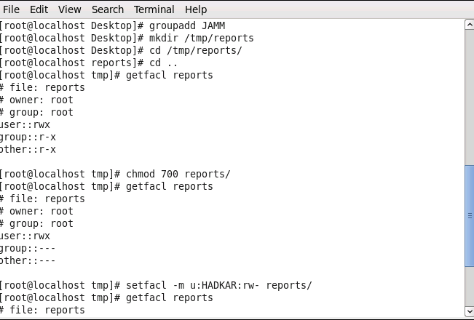

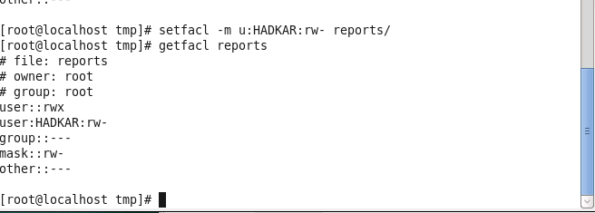

3.

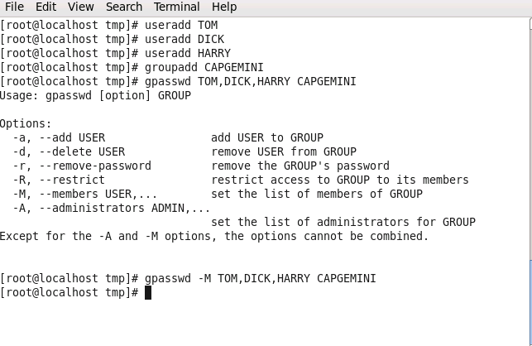 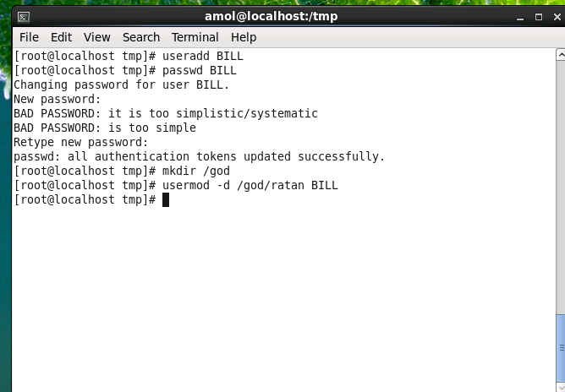

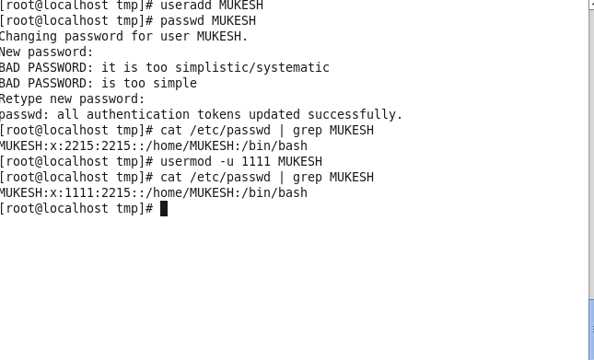

5.

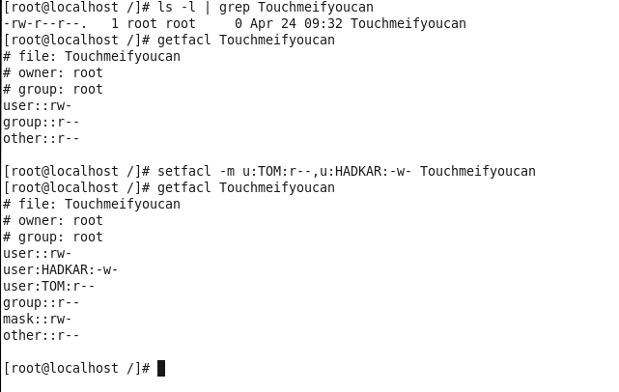

First create Capgemini group and then create /god directory

**PARTITION**

First Hard disk = sda

Second = sdb

Third = sdc

If we follow MBR it allows to 4 partition

If we follow GPT it allows to 16 partition

Steps:

First shutdown the machine

Click on edit virtual settings

Add Hard disk – next –next – 10gb next- finish

Power on VM

To see how many hard disk we have : fdisk –l

Fdisk /dev/sdb

Command : m

D – delete

M – print this menu

N – add a new partition

P - print the partition table

t- change a partition’s system id

w- write table to disk and exit

command : n

p

1

Enter

+1G

Command : p

P

2

+1G

For extended

Command : d

4

E

Enter

Enter

W to save the file

To know the kernel of update the kernel so the partition is updated or reboot.

Kpartx /dev/sdb

Fdisk –l

**HOW TO CREATE THE FILE SYSTEM:**

* Mkfs.ext2 /dev/sdb1
* Mkfs.ext3 /dev/sdb2
* Mkfs.ext4 /dev/sdb3
* Mkfs.vfat /dev/sdb5
* Mkfs.ext4 /dev/sdb6
* Mkfs.ext4 /dev/sdb7

**HOW TO CREATE THE MOUNT POINT:**

* Mkdir /data
* Mkdir /data1
* Mkdir /data2
* Mkdir /data3
* Mkdir /data4
* Mkdir /data5
* Mkdir /data6

**MOUTING:**

Mounting are of 2 types:

1. Temporary mounting
2. Permanent mounting

Temporary mounting is only for the session (until reboot).

* Mount /dev/sdb1 /data
* Df –hT
* Cd /data
* Pwd
* Touch 1 2 3 4 5 6
* Ll
* Reboot
* Df –hT
* Mount /dev/sdb1 /data
* Cd /data
* Ll

Permanent mounting:

* Vim /etc/fstab
* #proc

#partition

/dev/sdb1 /data ext2 defaults 0 0

/dev/sdb2 /data1 ext3 defaults 0 0

/dev/sdb3 /data2 ext4 defaults 0 0

/dev/sdb5 /data3 vfat defaults 0 0

/dev/sdb6 /data4 ext4 defaults 0 0

/dev/sdb7 /data5 ext4 defaults 0 0

:wq!

* Mount –a (no result is coming means no syntax error)
* Df –hT

**LVM reducing and increasing**

**Increasing:**

* Lvresize –L +5G –n /dev/parents/son

Resize2fs /dev/parents/son

Reducing :

Umount /son

E2fsck –ff /dev/parents/son

Resize2fs /dev/parents/son 10G

Lvreduce –L – 5G /dev/parents/son

**SWAP PARTITION:**

* Free –m (m mean show memory in megabytes)
* **Shutdown**
* Add HD 2.0GB and Power on VM
* **Fdisk –l**
* **Fdisk /dev/sdc**
* **Command : n**
* **P**
* **1**
* **Enter**
* **Enter**
* **T ( for change id)**
* **L**
* **82 (Linux/swap)**
* **p**
* **w**
* Kpartx /dev/sdc
* **Mkswap /dev/sdc1 (This will make partition as swap)**
* **Swapon –s (This is to see the status)**
* **Swapon /dev/sdc1 (To on the swap partition)**
* **Swapon –s**
* **Vim /etc/fstab (For permanent mounting)**
* **/dev**

**#swap**

**/dev/sdc1 swap swap defaults 0 0**

**:wq!**

* **Mount –a**
* **Df –hT**
* **Swapon –s**
* **Free –m**

**LOGICAL VOLUME MANAGER (LVM)**

**10GB 15GB LV (LOGICAL VOLUME)**

**30 GB VG (VOLUME GROUP)**

**10GB 10GB 10GB PV (PHYSICAL VOLUME)**

**10GB 10GB 10GB HDD**

* **SHUTDOWN AND ADD 3 HDD OF 10 GB**
* **POWER ON VM**
* **Fdisk –l**
* **Fdisk /dev/sdd**
* **Command : n**
* **P**
* **1**
* **T**
* **L**
* **8e**
* **W**
* **Fdisk /dev/sde**
* **Command : n**
* **P**
* **1**
* **T**
* **L**
* **8e**
* **W**
* **Fdisk /dev/sdf**
* **Command : n**
* **P**
* **1**
* **T**
* **L**
* **8e**
* **W**
* **Kpartx /dev/sdd**
* **Kpartx /dev/sde**
* **Kpartx /dev/sdf**
* **Fdisk –l**

**CREATE PHYSICAL VOLUME:**

* **Pvcreate /dev/sdd1 /dev/sde1 /dev/sdf1**

**TO VIEW THE PHYSICAL VOLUME**

* **PVS**
* **OR PVDISPLAY**

**CREATE VOLUME GROUP:**

* **Vgcreate amol /dev/sdd1 /dev/sde1 /dev/sdf1**
* **Vgs or vgdisplay (to view volume group)**

**CREATE THE LOGICAL VOLUME:**

* **Lvcreate amol –L +10G –n prem**
* **Lvcreate amol –L +15G –n priyal**
* **Lvs (for display)**
* **Lvdisplay**

**CREATING THE FILE SYSTEM:**

* **Mkfs.ext4 /dev/amol/prem**
* **Mkfs.ext4 /dev/amol/priyal**

**CREATING THE MOUNT POINT:**

* **Mkdir /son**
* **Mkdir /daughter**

**DO THE PERMANENT MOUNTING:**

* **Vim /etc/fstab**
* **#lvm**

**/dev/amol/prem son ext4 defaults 0 0**

**/dev/amol/priyal daughter ext4 defaults 0 0**

**:wq!**

* **Mount –a**
* **Df –hT**
* **Cd son (For extending)**
* **Touch teja**
* **Ll**
* **Cd ..**
* **Df –hT**

**EXTENDING THE LOGICAL VOLUME:**

* **Lvresize –L +1G –n /dev/amol/prem**
* **Lvs**
* **Lvdisplay**
* **Df –hT**
* **Resize2fs /dev/amol/prem (for updating)**
* **Df –hT**

**/device to mount /mount point /fs type /**

**/dev/amol/priyal daughter ext4 defaults 0 0**

* **E2label /dev/sdb1 Linux**
* **E2label /dev/sdb1**

**DISK QUOTA**

* **Df –hT**
* **To unmount**
* **Go to /etc/fstab**
* **Comment it**
* **Unmount /data5**
* **Mkfs.ext4 /dev/sdb7**
* **Mkdir /quota**
* **Mount –o usrquota /dev/sdb7 /quota/**
* **Mount**
* **Chmod 777 /quota/**
* **Ls –ld /quota/**
* **Fdisk –l**
* **Fdisk /dev/sdg**
* **N**
* **P**
* **1**
* **W**
* **Kpartx /dev/sdg**
* **Mkfs.ext4 /dev/sdg1**
* **Mkdir /quotamount**
* **Chmod 777 /quotamount/**
* **Ls –ld /quotamount/**
* **Mount –o usrquota,grpquota /dev/sdg1 /quotamount/**

**CREATE THE QUOTA DATABASE FILE:**

**ADD 1 GB HDD AND POWER ON VM**

* **Quotacheck –info**

**-c create files**

**-u check user files**

**-g check group files**

**-v print more information**

* **Quotacheck –cgv /dev/sdg1**

**HOW TO RECOVER THE ROOT PASSWORD:**

* **Reboot**
* **When Boot screen will come press down arrow**
* **E (3 lines will come and select 2nd line)**
* **E and give space type 1 and press enter**
* **B**
* **Passwd and press enter and set new password**

**HOW TO BLOCK UNWANTED USERS BY USING SINGLE USER MODE**

* **Reboot and login**
* **Vim /boot/grub/grub.conf**
* **Goto hiddenmenu and press enter and type**

**Password 123456**

:wq!

* **Reboot and press down arrow key when boot screen appears**

**Type p and type 123456**

**NETWORKING**

**By default RHL networking is disable in rhl6 or 7**

**Enable the network**

* **Vim /etc/sysconfig/network-scripts/ifcfg-eth0**

**ONBOOT = yes**

**:wq!**

* **Setting the IP address:**

**Setup**

**Select network configuration then**

**Select run tool = enter**

**Device configuration = enter**

**Etho0 = enter**

**Use dhcp [*] (use space to delete the *)**

**Assign IP**

**192.168.0.254**

**255.255.255.0**

**192.168.0.254**

**Select OK = save= save & quit=quit**

* **To register the network service:**

**Service network restart**

* **To initialize the kernel:**

**Chkconfig network on**

**Service network status**

**Ifconfig**

**Ping 0 or IP –c 2**

**CHANGING THE HOST NAME:**

**Two ways:**

1. **Temporary**

* **Hostname server**

1. **Permanent**

* **Vim /etc/hosts**

**192.168.0.254 server**

**192.168.0.1 client**

**:wq!**

* **Vim /etc/sysconfig/network**

**HOSTNAME = server**

**:wq!**

* **Hostname server**
* **Bash (it will change immediate)**

**OR**

* **Reboot**
* **Do the above step in client also**

**SOFT LINK AND HARD LINK**

* **Come to desktop cd ..**
* **Ll**
* **Cat > 1**

**Hi**

* **Ll**
* **Ls –li 1**
* **Now creating the hard link**
* **Ln 1 2**
* **Ls –li 1 2**
* **Cat > 2**

**Hello**

* **Cat 1**
* **Rm –rfv 2**
* **Cat 1**
* **Now creating softlink**
* **Ln –s 1 2**
* **Ls –li 1 2**
* **Cat >> 2**

**Done for you?**

* **Cat 1**
* **Rm –rfv 1**
* **Cat 2**
* **Ll**

**HARD LINK:**

1. **Inode number will be the same for both files.**
2. **When we edit one file other file will automatically edited.**
3. **We cannot identify from which file which file is generated**
4. **If we delete any file there is no impact on other file**

**SOFT LINK:**

1. **Inode number is different for both files.**
2. **We can identify form which file which file is generated**
3. **If we edit one file other file is also get edited**
4. **If we deleted the link file nothing will happen but if we delete the source file link will be unaccessible.**

**YUM SERVER**

**Red hat package manager – rpm**

1. **Mount the DVD**
2. **RC on DVD -> Open in Terminal**
3. **Cd Packages/**
4. **Pwd**
5. **Rpm –ivh delt tab**
6. **Rpm –ivh python-delta tab**
7. **Rpm –ivh ftp tab**
8. **ftp has one daemon thread which is known as vsftpd**
9. **Rpm –ivh vsftpd tab**
10. **Tpm –ivh create tab**
11. **Cd ..**
12. **Mkdir –p /var/ftp/pub/rehl6**
13. **Cp –rfv * /var/ftp/pub/rehl6/**
14. **To create repository**

**Createrepo –g repodata/6 tab /var/ftp/pub/rehl6**

1. **Vim /etc/selinux/config**

**SELINUX = disable**

**:wq!**

1. **Reboot**

**TO CONFIGURE FIREWALL**

1. **System-config-firewall**

**Disable -> apply**

1. **Open browser**

[**ftp://server**](ftp://server) **or** [**ftp://192.168.0.254**](ftp://192.168.0.254)

1. **Service vsftpd restart**

**Chkconfig vsftpd on**

**Service vsftpd status**

1. **Again perform step 18**

**YUM CLIENT IN SERVER**

1. **Cd /etc/yum.repos.d/**
2. **Ll**
3. **Rm –rfv \***
4. **Ll**
5. **Vim server.repo**

**[RHEL6]**

**Name=RHEL6**

**Baseurl=copy the path from browser from step 20**

**Enabled=1**

**Gpgcheck=0**

**:wq!**

1. **Yum clean all**
2. **Yum list all**
3. **Yum makecache**

**Now yum server is ready**

**YUM CLIENT IN CLIENT**

1. **Rc ON DVD -> Open in terminal**
2. **Perform 3, 4, 5**
3. **Rpm –ivh ftp tab**
4. **Rpm –ivh vsftpd tab**
5. **21,22,23**
6. **Vim client.repo**

**[RHEL6]**

**Name=RHEL6**

**Baseurl=copy the path from browser from step 20**

**Enabled=1**

**Gpgcheck=0**

**:wq!**

1. **Yum clean all**
2. **Yum list all**
3. **Yum makecache**
4. **Yum install telnet* -y**
5. **telnet server**
6. **w**

**INSTALLING TELNET SERVER IN CLIENT AND SERVER**

1. **rpm –qa | grep telnet\***
2. **yum install telnet\***
3. **By default telnet is disabled in linux**

**To enable**

**Vim /etc/xinetd.d/telnet**

**Disable=no**

**:wq!**

1. **Service xinetd restart**
2. **Chkconfig xinetd on**
3. **telnet 0**
4. **pwd**
5. **w**

**PROCESS MANAGEMENT**

1. **top**
2. **d and type 1000 (1000 second delay)**
3. **x**
4. **k 3131(pid of top )**

**signal[15] is a gentle kill (complete the task then killed)**

**signal[9] is a forcefully killed**

**HOW TO INCREASE AND DECREASE THE PRIORITY**

**Renice value is between -20 to 19**

1. **top**

**r**

**3943 -20 (decrease)**

**3142 10 (increase)**

**CRONTAB**

**Crontab is use to schedule a job**

1. **Eg. 10th june 08.30 AM**

**30 08 10 06 * /home/Ramesh/full-backup**

1. **Backup twice a day on 11.00 am and 16.00 pm**

**00 11,16 * * * /home/Ramesh/bin**

1. **Create a cron for delete all files in a folder every 30 min on all working days of the third quarter**

**\*/30 09-18 * * 10-12 1-5 rm –rfv /path**

1. **Create a cron for delete all files in a folder every 30 min on all non-working days of the third quarter**

**\*/30 0-9,18-23 * * 10-12 0,6 rm –rfv /path**

**:wq!**

* **Service crond restart**
* **Chkconfig crond on**
* **Crontab –l**

**NTP SERVER**

1. **INSTALL ALL PACKAGES WHICH ARE NECESSARY:**

* **Yum install ntp* -y**

1. **CONFIGURING THE SERVER:**

**Vim /etc/ntp.conf**

**:se nu**

**18. remove #**

**19. restrict defaults ignore**

**22. remove that server and put our server ip**

**Server 0.192.168.0.254**

**And remaining put # for disable**

**23. #**

**24. #**

**25. #**

**26. server 127.127.1.0 iburst**

**:wq!**

1. **RESTART THE SERVICES:**

* **Service ntpd restart**
* **Chkconfig ntpd on**
* **Service ntpd status**

**IN CLIENT PERFORM ALL THE ABOVE 3 STEPS**



* **Date**
* **Date –s “01/01/2000 10.10.10”**
* **Date**
* **To update from server**

**Ntpdate –u 192.168.0.254**

* **Date**

**CONFIGURATION OF LOG SERVER**

1. **INSTALL ALL THE NECESSARY PACKAGES:**

* **Yum install rsyslog* -y**

1. **CONFIGURING THE SERVER**

* **Vim /etc/rsyslog.conf**

**:se nu**

1. **Remove #**
2. **Remove #**

**17.Remove #**

**18.remove #**

**45. authpriv.* /var/log/secure_log**

**:wq!**

1. **RESTART THE SERVICES:**

* **Service rsyslog restart**
* **Chkconfig rsyslog on**
* **Service rsyslog status**

**Go to client**

**Again do all th above steps**

**But in step 2:**

**79. *.* @@192.168.0.254:514**

**:wq!**

**Again go to server**

* **Tail –f secure_log**

**Again go to client**

* **Useradd hitlar**
* **Passwd hitlar**

**And now we can see the changes are visible in the server file.**

**RAID**

**There are two types of RAID are available:**

**Hardware RAID and Software RAID**

**Except striping the hard disk size should be the same for all other RAIDs**

**Now configuring the software RAID:**

* **Yum install mdadm* -y**
* **Fdisk –l**
* **N**
* **P**
* **1**
* **T**
* **Fd**
* **W**

**Do the above steps for the hdd.**

* **Mdadm –c /dev/md0 –n2 /dev/sdc1 /dev/sdd1 –l1**

**Y**

* **Mdadm –D /dev/md0**

**CREATE FILE SYSTEM ON RAID META DEVICE:**

* **Mkfs.ext4 /dev/md0**

**NOW CREATING THE MOUNT POINT:**

* **Mkdir /raid1**
* **Mount /dev/md0 /raid1**
* **Df –hT**
* **Cd /raid1/**
* **Cat > file1**

**Hi**

* **Init 6**
* **Fdisk –l**
* **Vim /etc/fstab**

**#RAID1**

**/dev/md127 /raid1 ext4 defaults 0 0**

**:wq!**

* **Mount –a**
* **Df –hT**
* **Df –h**
* **Df**
* **Reboot**
* **Df –hT**
* **Cd /raid1/**
* **Ll**
* **Cat file1**

**WHEN USER ADD DEVICE AS A SPARE:**

* **Mdadm -a /dev/md0 /dev/raid1**
* **Add 2 hdd of 12 GB**
* **Fdisk –l**
* **Fdisk /dev/sdd**

**N**

**P**

**1**

**Enter**

**Enter**

**Fd**

**P**

**W**

* **Do same for /dev/sde**
* **And perform kpartx**
* **Mdadm –a /dev/md127 /dev/sde1**

**Mdadm –D /dev/md127**

* **Mdadm –a /dev/md127 /dev/sdd1**

**Mdadm –D /dev/md127**

**TO DISABLE ONE HDD FIRST WE HAVE TO MAKE THAT HARD DISK AS FAULTY**

* **Mdadm /dev/md127 –f /dev/sdc1**

**Mdadm /dev/md127**

* **Mdadm /dev/md127 -r /dev/sd1 (to remove hdd )**

**Mdadm /dev/md127**

**DATA BACKUP**

* **Cd ..**
* **Mkdir /testing**
* **Cd /testing/**
* **Mkdir ram{1..10}**
* **Ll**
* **Yum install dump* -y**
* **Cd ..**
* **Dump -0af /testing.dump /testing/**
* **Ls –l**
* **Cd /testing**
* **Ll**
* **Rm –rfv ram1 ram2**
* **Restore –if /testing.dump**
* **Restore> pwd**

**>cd /testing**

**>ls**

**>add ram1**

**>add ram2**

**>Extract**

**1**

**N**

**>quit**

**> cd /testing**

**ll**

**VNC SERVER**

1. **Install the packages:**

* **Yum install pixman pixman-devel libXfont –y**
* **Yum install vnc-server –y**

1. **Create the VNC user and set password for it:**

* **Useradd vncuser1**
* **Passwd vncuser1**
* **Su – vnuser1**
* **Vncpasswd**

1. **Configuring the VNC server for users**

* **Vim /etc/sysconfig/vncservers**
* **:se nu**

**18. remove #**

**19. remove #**

**Copy line 19 by Esc+1yy**

**To paste Esc+p**

**18. VNCSERVER=”1.vncuser1 2.vncuser2”**

**19. VNCSERVERARGS[1]=”-geometry 800x600”**

**20. VNCSERVERARGS[2]=”-geometry 1024x768”**

**:wq!**

1. **Starting the service:**

**Service vncserver start**

**GO TO CLIENT MACHINE**

1. **Install the packages:**

* **Yum install tiger* -y**

1. **Access the VNC user:**

**Vncviewer 192.168.0.254:1**

**IP TABLES**

**Block the ssh using iptables:**

* **Ssh root@server**
* **Pwd**
* **W**
* **Vi firewall**

**Iptables –F**

**Iptables –A INPUT –p tcp –dport 22 –j REJECT**

**:wq!**

* **Sh firewall**
* **Ssh root@server**

**Crontab */15 09-18 *1-5 4-6 –rfv /tmp**